Programming Lesson

First you have to create a database on the firebase site, you must have a google account to be able to do this. We created a custom account [catanidev@gmail.com](mailto:catanidev@gmail.com). Then in Android Studio navigate to the dropdown menu **Tools** and select **Firebase**. Next click on the database option, it will prompt you to login in using your credentials to which you created the database on the firebase site. Select the database that you previously created on the site and it will join the project to the database. Next you have to add the gdx-fireapp dependency to the android build.gradle.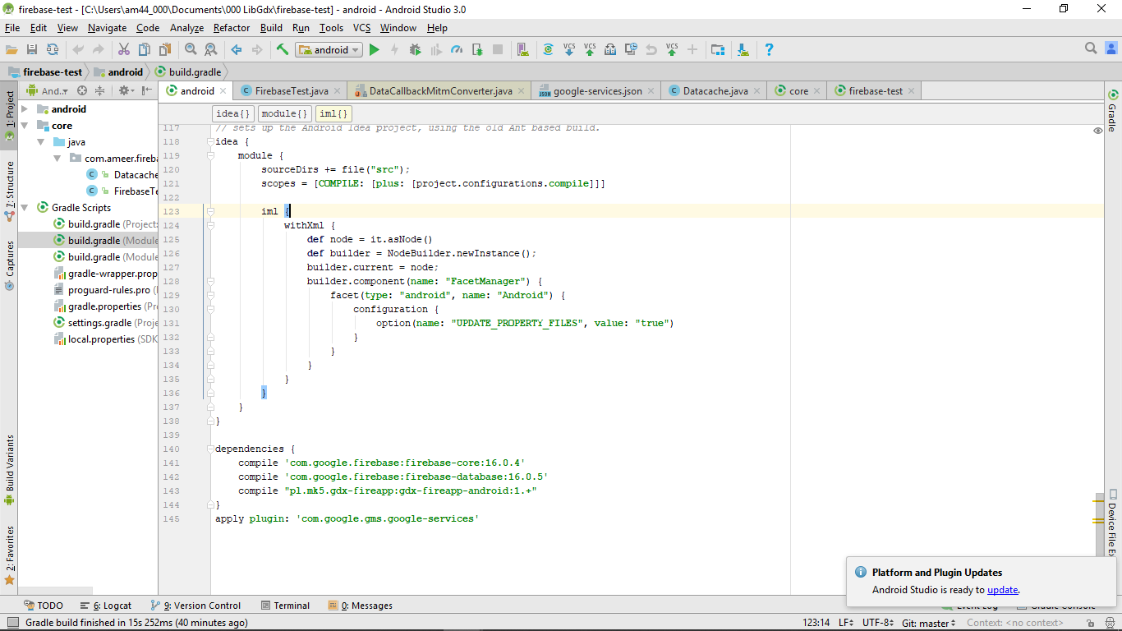

Next you have to create a POJO (plain old java object) class which will be used to interact with the database.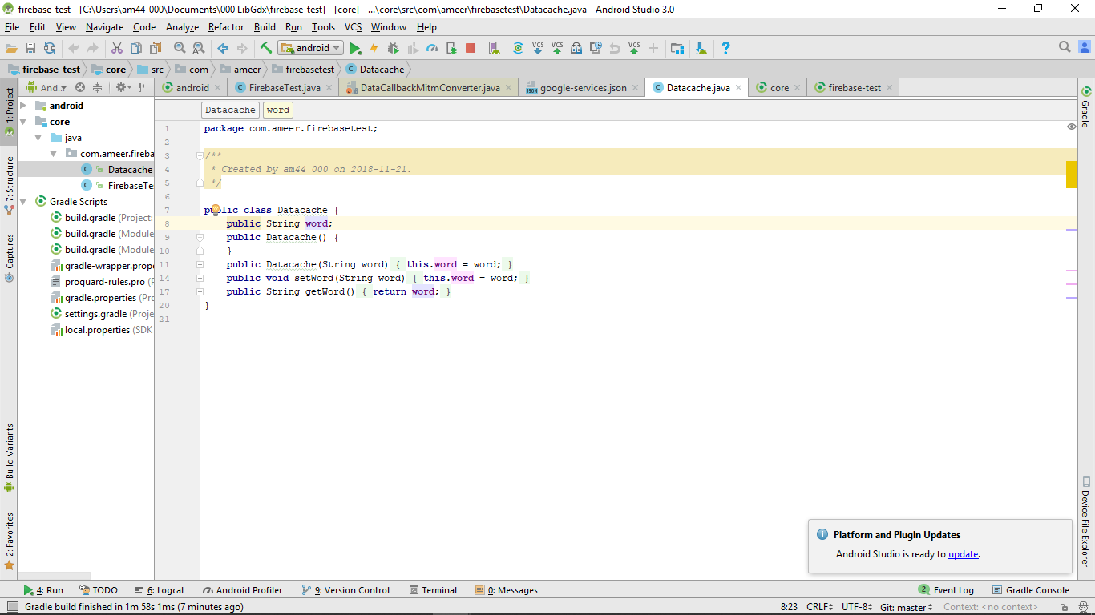

Important! The values in your class must be strings when uploaded or downloaded from the database. You can typecast them after.

Next you can use the following functions to interact with the database

